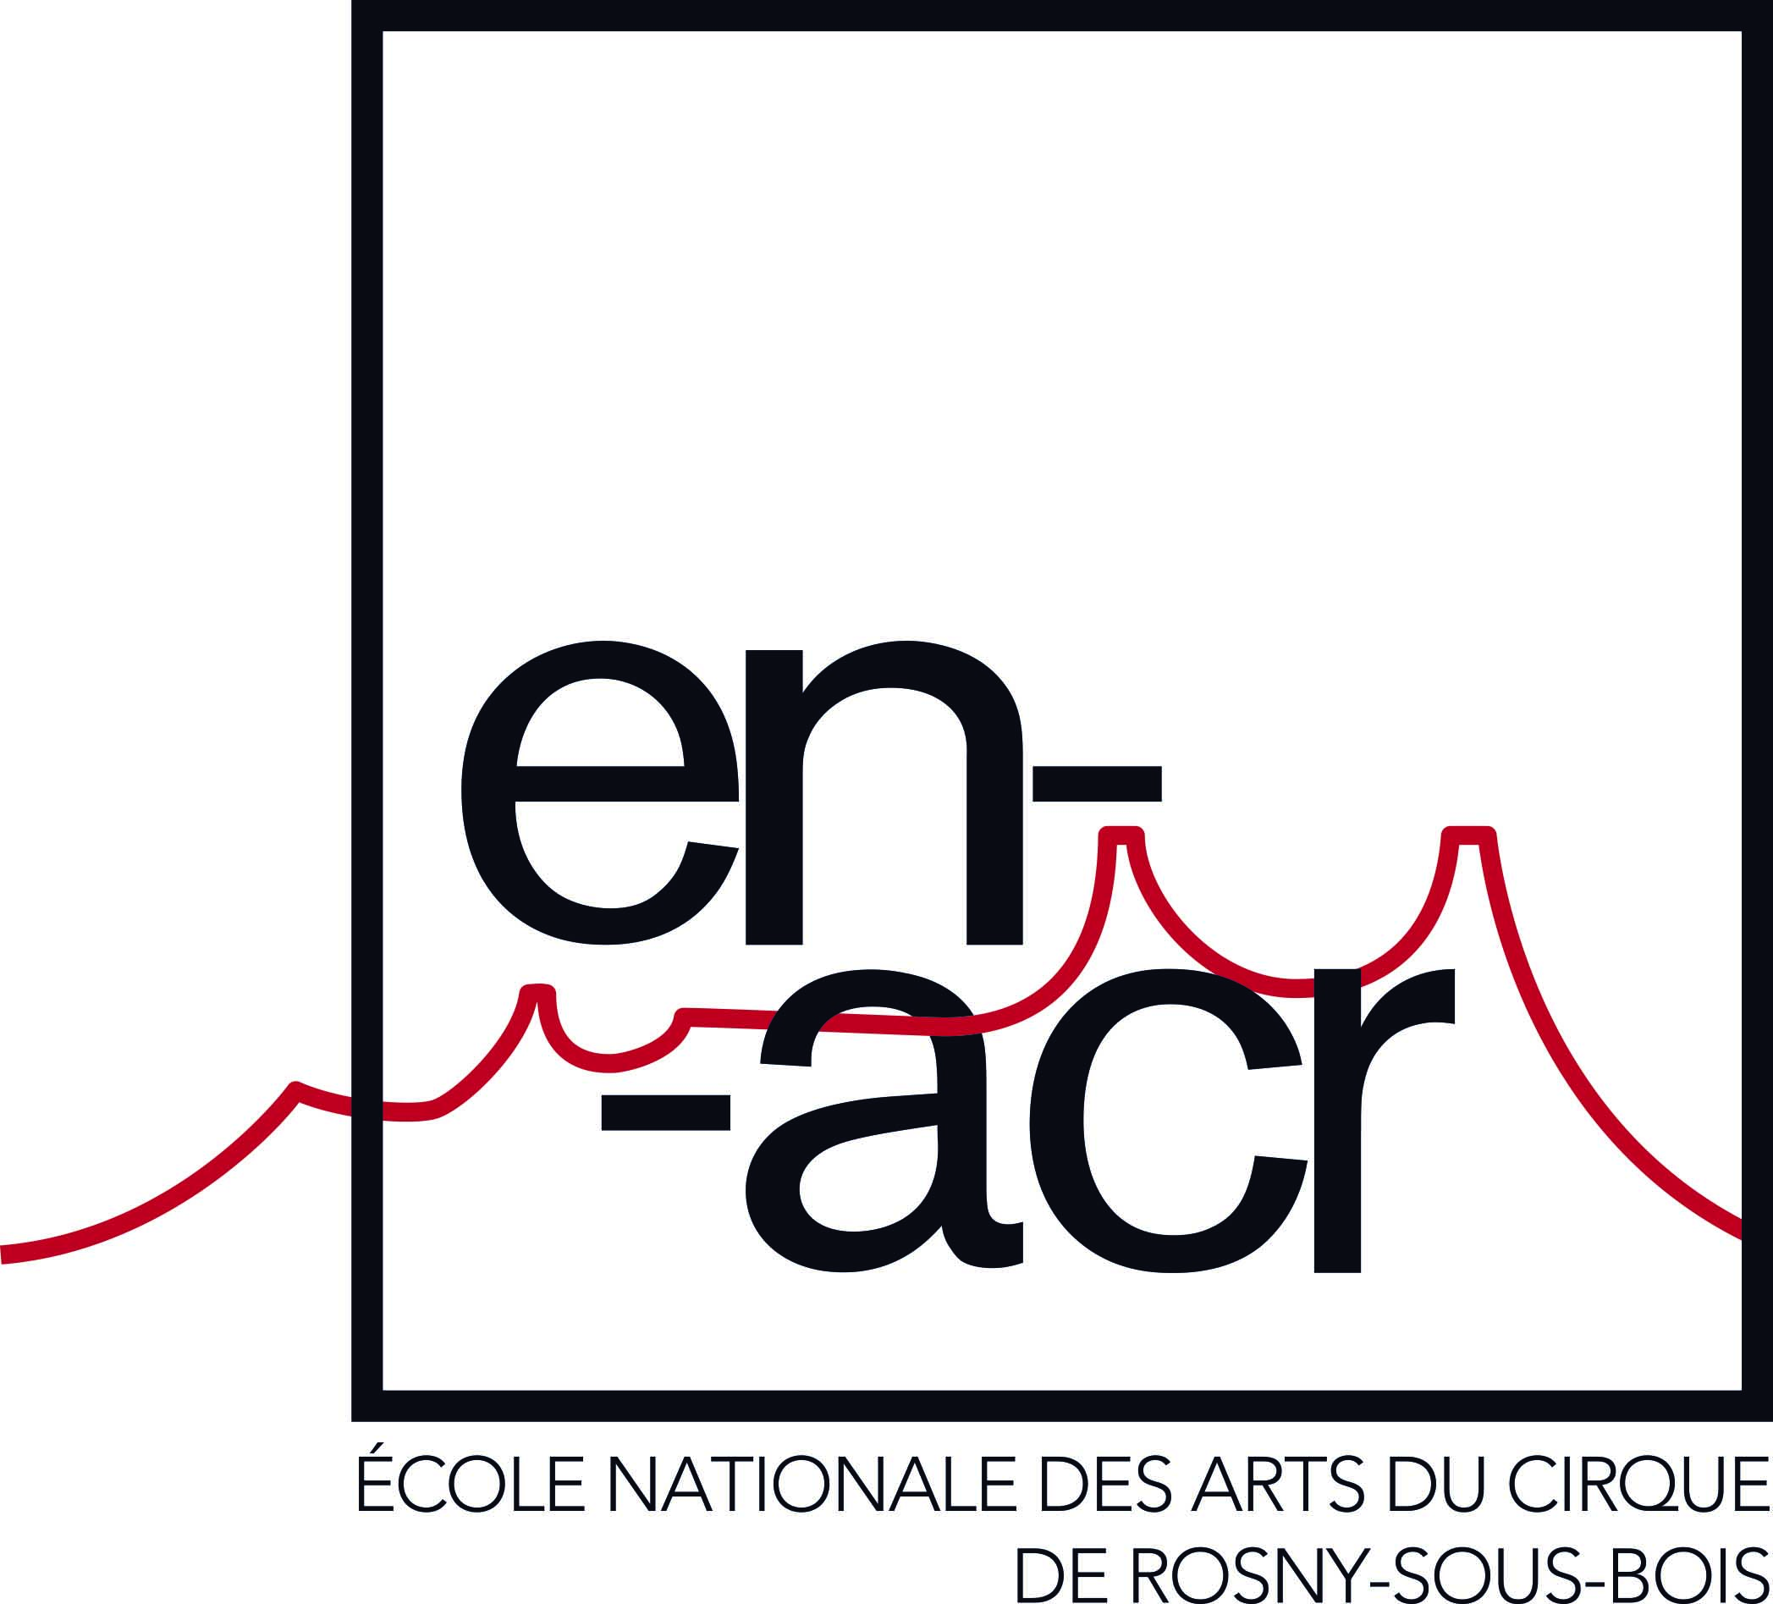

BATC – TRAINING PROGRAM

Training objectives : 2
First year objectives : 2
Second year objectives : 2
Training duration : 2
Audience: 2
Prerequisites: 2
Admission exam 2
Organization of studies: 3
Vocational courses (570h in the 1st year, 635h in the 2nd year) 3
Artistic courses (290h in the 1st year, 320h in the 2nd year) 3
General courses (180h in 1st year, 140h in 2nd year) 3
Evaluation: 3
Pedagogical team : 4
Schedules and training locations : 4
Contact : 5

Training objectives :

- To train circus artists
- To obtain the an artistic certificate in circus techniques ( = BATC, level 4)
The BATC is a level 4 state diploma, registered in the National directory of professional certifications (RNCP 23909) The summary of this certification and the reference frame of competences are available at https://www.francecompetences.fr/recherche/rncp/23909/

First year objectives :
- The acquisition of technical fundamentals : trampoline, acrobatics, balances, physical preparation
- The acquisition of artistic fundamentals: dance, singing, theatrical play
- The informed choice of a speciality (all can be considered except for work with animals, magic and clowning)
- Openness to the diversity of professional practices: social circus, stage management, collective creation, individual performance

Second year objectives :
- Reinforcement of the technical level, in particular in the chosen speciality
- The conscious and singular articulation of technique and artistry
- Professional determination : the choice of a higher school, preparation for competitions/auditions or professional integration

Training duration :

From September 2, 2024 to July 15, 2026
The calendar, inspired by the rhythm of the Paris area, is specified at registration.

Audience:

Prerequisites:
- be between 17 and 23 years old and initiated into the practice of circus or sport
- pass the entrance exam
- be physically fit for intensive circus practice

Admission exam

Reminder of the competition calendar

-Online application form : 5 february 2024
-Submission of applications deadline : 4 March 2024 (questionnaire to be completed and videos to be sent)
-Announcement of successful candidates 29 April 2024
-Selection course at ENACR from 6 to 10 May 2024
-Announcement of successful candidates on the last day of the selection course

Contact : concours.enacr@gmail.com

Number of students: 18 students maximum per class

Organization of studies:

The teaching revolves around three poles:

Vocational courses (570h in the 1st year, 635h in the 2nd year)
- circus techniques: physical preparation, acrobatics, trampoline, balances, discovery of specialities
- specialization in the practice of an apparatus or in a discipline
- professional experiences : stage management at a festival, spectator practice, collective shows, presentation of circus acts..

Artistic courses (290h in the 1st year, 320h in the 2nd year)
- musical expression
- body language
- dramatic expression
- applied arts (scenography, masks)

General courses (180h in 1st year, 140h in 2nd year)
- French
- English, French as a foreign language
- sciences: anatomy, dietetics
- applied mathematics

Teaching methods
Teaching is done in person, except in cases of force majeure, at ENACR : in the marquee and the classrooms. The premises and technical equipment are described on the website.

Artistic and general lessons are collective. The technical lessons are individualized and specialized after a few months.

As the training progresses, teachers of circus and artistic techniques work together to provide personalized support for the student's project.

The pedagogical management and the teacher referent of the class are the privileged interlocutors of the student in his or her learning.

Evaluation:

The assessment of acquired learning is done in the form of :
- continuous monitoring by the trainers
- final assessment during the public presentation of end-of-training work.

All the blocks of competence must be acquired, partial validation is not possible. If a student has not been able to validate certain blocks for medical reasons, a repeat exam may be offered to him or to her.

Pedagogical team :

Permanent or Regular Team:

- Christian Etienne: Artist, specialized in aerial acrobatics; teacher of applied mathematics
- Brice Porquet: Artist, teacher in aerial and acrobatic techniques.
- Sylvain Laurent: Artist specialized in juggling, wheels, and cycles.
- Patrick Mattioni: High-level gymnast, teacher in acrobatic techniques, Chinese pole, and aerial disciplines.
- Delphine Pain: Dancer and teacher of contemporary dance.
- Pascal Sogny: Artist, high-level trampolinist, teacher in circus techniques, including teeterboard, Russian bar, trampoline.
- Dominique D'Angelo: Artist and teacher in handstand.
- Agnès Brun: Artist and teacher in acrobatic techniques.
- Sigolène De Chassy: Scenographer and plastic artist.
- Charlotte Kah: Artist, dancer, and teacher in classical dance.
- Jérôme Dupin: Artist, stage director, and acting teacher.
- Guillaume Servely: Artist, stage director, and acting teacher.
- Jonathan Sly: English teacher.
- Constance Biasotto: Director and French teacher, teaching writing and dramaturgy.
- Antoine Locuratolo: Physical trainer and sports educator, sciences teacher for nutrition and anatomy classes.
- Cyrille Roussial: PhD Student, teacher in critical analysis

The CV of the teachers can be consulted on the website.
If necessary, the school also calls upon other qualified and specialized teachers.

Schedules and training locations :

Courses take place at the ENACR site :
22 rue Jules Guesde – 93110 Rosny-sous-bois – FRANCE
The workspaces are described on the ENACR website, in particular the marquee.

Classes from Monday to Friday, from 9 a.m. to 5 or 6 p.m.

The professional experiences may involve :
- working on weekends and evenings
- trips in France and abroad. (provide a valid passport)
- compliance with the specific regulations of these places or activities, particularly in terms of health.

Contact :

mapy.mouisson@enacr.com
01 56 63 05 49

